Send commercial invoice and packing slip by FTP folder for GTMS
Functional & Design Specification Num:

Application: ERP

Module: OM

Creation/Revision History

Rev. | Description/Details | Created/Updated By | Date | Approved By
1 | Technical function creation |  | 29/03/2015

A. Functional Specification 3
A.1 Basic Business Needs 3
A.2 Related Documents 3
A.3 Solution Logic 3
A.4 Solution Components 3
B. Technical Specifications 4
B.1 Solution Technical Components 4
B.2 Technical Components 4
B.3 Tables 4
B.4 Views 4
B.5 Reports 5
B.6 Programs 5
B.7 Forms 6
B.8 Other Components 6
C. Setup 7
C.1 Setup Components 7
C.2 Each Component Description 7
D. Restriction/Incompatibility 8
E. Testing 9
F. Additions/Updates 10
F.1 Functional Spec updates 10
F.2 Technical Spec updates 10
G. Approvals 11

Functional Specification

In order to enable the Process Weaver ( The supplier of the Global Trade Management System ) to get the shipping documents ( Packing List and Commercial Invoice ) which are generated at SSYS , it is required to create a mechanism which will send those documents as soon as the GTMS updates the Waybill value in Oracle .

Basic Business Needs
Enter Basic Business Need of the customizations

Related Documents
No. | Document Title | Revision | Date
[1] |  | Ver. <number>
[2]
[3]

Solution Logic

Logic Description

In order to enable the Process Weaver (The supplier of the Global Trade Management System) to get the Shipping Documents (before sending them to the carriers)
When PW will populate the Waybill field, PW will execute the procedure XXWSH_GTMS_SEND_SHIP_DOCS_PKG. send_shipping_docs in order to run the concurrent which creates those documents (Packing List and Commercial Invoice). The output will be sent to the SFTP Folder which will be located and handled by PW.

- The process above will be done per Delivery.
- The documents will be sent depending and according the shipper organization- see the details below.
- The shipping documents headers should be named as following
  - CI_<DeliveryNo>.pdf
  - PL_<DeliveryNo>.pdf

The shipping documents should be sent to the following SFTP folders
ftp:// 10.16.2.140/Outbound - for export processes

SFTP folder

- The location and ownership of this SFTP folder will be Process Weaver
- The access details for the SFTP folder :

- The IP address : 67.192.179.134
- User : stratasys
- Password : fetrudRA4a

Test folder : /Test/incoming
Production: /incoming

- In case of failure of one of the data background transferring process the failure information should be sent by a mail, according to the relevant Operating Unit, to the recipients who defined in the new VS. XXWSH_GTMS_USERS_MAILING_LIST_FOR_IL_FAILURES.
The code has to refer ( per VS line ) the Enabled flag and the date ranges fields From and To .

Solution Components
Number | Component  Type | Component  Name | Organization | New / Update
1 | Report | XX SSUS: Commercial Invoice PDF Output | No dependency on organization | Add to new process
2 | Report | XX: Packing List Report PDF Output  (XXWSHRDPAK) | Operating Unit = 81 (IL) | Add to new process
3 | Report | XX SSUS: Packing List Report PDF Output via Mail  (XXSSUS_WSHRDPAKSM) | Operating Unit = 737 (US) | Add to new process
4 | Report | XX: Packing List Report PDF Output via Mail  (XXWSHRDPAKSM) | Operating Unit = 103 (AP) | Add to new process
5 | Report | XX: Packing List Report PDF Output via Mail Japan  (XXWSHRDPAKSM_JPN) | Operating Unit = 683 (JP) | Add to new process

In order to get the operating unit given the ORGANIZATION_ID from the delivery use the following elements:

- Take the organization ID from the delivery table WSH_NEW_DELIVERIES ( select ORGANIZATION_ID from WSH_NEW_DELIVERIES where DELIVERY_ID = & )

- Get the OU by the function: XXHZ_UTIL.GET_INV_ORG_OU (P_ORGANIZATION_ID )

- Choose the relevant concurrent to be run according the next profile XXWSH_SEND_PACKING_LIST_ACCORDING_OU ( which connects between the OU to the concurrent name
  - This profile based on the lookup XXWSH_PACKING_LIST_DOCS_LIST

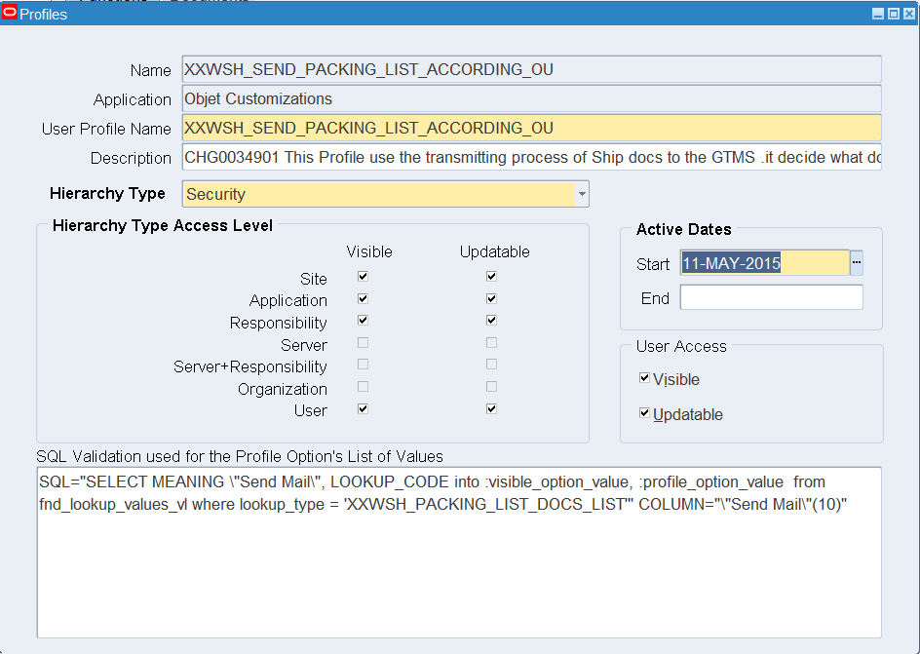
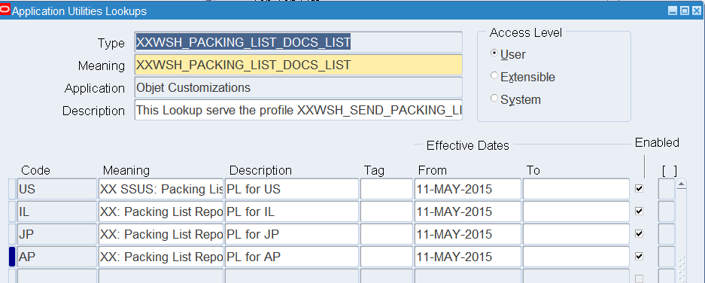

- In order to let PW to execute the FND_GLOBAL.APPS_INITIALIZE ( without the access to entities which are irrelevant to GTMS processes ) , required to create a new package with 2 procedures as following :

The new package should be named as: XXWSH_GTMS_UTIL_PKG

The procedures:
      - The first procedure will be named as APPS_INITIALIZE
This function will get the 3 following parameters:
- USER_ID
- RESP_ID
- RESP_APPL_ID

      - The second procedure will be named as MO_GLOBAL_INIT
This function will get the parameter: MODULE_CODE

The origin package and function of FND_GLOBAL.APPS_INITIALIZE is the following

Declare
begin
FND_GLOBAL.APPS_INITIALIZE (user_id => 18659 ,
resp_id => 53982 ,
resp_appl_id => 201 );
mo_global.init('PO');
end;

Technical Specifications

Solution Technical Components

2 New concurrent programs will be built:
      - A host program that copy concurrent request output to destination folder
      - A shell program that will submit shipping documents program and also copy output file to shared directory - /mnt/oracle/wsh/gtms/outgoing.

A Bpel process will monitor folder /mnt/oracle/wsh/gtms/outgoing/ and upload to GTMS server
All *.pdf files

We will supply a plsql procedure that will submit the shell program. GTMS should use this procedure in the code where they populate the Waybill field.

Technical Components

Object Type | New/Update | Object Name | Object Role
Profile | New | XXWSH_SEND_PACKING_LIST_ACCORDING_OU
Profile | New | XXWSH_SEND_COMMERCIAL_INVOICE
Profile | New | XXWSH_GTMS_SHARED_DIRECTORY
Profile | New | XXWSH_SEND_SHIPP_DOCS_USER
Profile | New | XXWSH_SEND_SHIPP_DOCS_RESP
DB Package | New | XXWSH_GTMS_SEND_SHIP_DOCS_PKG
DB Package | New | XXWSH_GTMS_UTIL_PKG
Bpel |  | gtms_ftpOut
Trigger | New | XXWSHGTMS_WAYBILL_POPULATION_TRG
Concurrent Program | New | XXWSH_SEND_SHIPPING_DOCS
Concurrent Program | New | XXFNDCPCONCOUTPUT
Host File | New | XXFNDCpConcOutput
Custom pll
Other object

Bpel

GTMS Server information

Weblogic : Create ftp connection eis/Ftp/gtms

Env | Server IP | User | password
Test | 10.16.2.140 | strat | Stratasys123
Prod

Weblogic : Create ftp connection eis/Sftp/gtms

Env | Server IP | User | password | Port
Prod/test | 67.192.179.134 | stratasys | fetrudRA4a | 22

BPEL

Bpel Process | gtms/gtms_ftpOut  util/DVM_Profile (mail error distribution)
Local server location | /mnt/oracle/wsh/gtms/outgoing/
Arc folder | /mnt/oracle/wsh/gtms/outgoing/arc
File to transfer | *.pdf
( Test Env)  FTP server Path | Gtms folder Path | File name convention
( Test Env)  FTP server Path | Test/inbound | *.pdf
(prod Env)  FTP server Path | OraShippingDocs | *.pdf

util/DVM_Profile
add entry for error handling : mail_gtms_ftpOut

Profiles

Profile Name  Profile User Name | Purpose
XXWSH_SEND_PACKING_LIST_ACCORDING_OU  XX: WSH Send Packing List According OU | The profile is managed by organization level only. For each organization it defines the correct Packing List concurrent program.
XXWSH_SEND_COMMERCIAL_INVOICE  XX: WSH Send Commercial Invoice | Hold name of commercial invoice program. Currently there is one program for all OU.
XXWSH_GTMS_SHARED_DIRECTORY  XX: WSH GTMS Shared Directory | Hold path of GTMS shared directory, where shipping documents should be saved so Bpel process fill move them by FTP to GTMS server.
XXWSH_SEND_SHIPP_DOCS_USER  XX: WSH username for sending shipping documents | Determine what user to use in order to submit requests from code
XXWSH_SEND_SHIPP_DOCS_RESP  XX: WSH responsibility for sending shipping documents | Determine what responsibility to use in order to submit requests from code

Packages
Package Name | XXWSH_GTMS_SEND_SHIP_DOCS_PKG

Procedure Name | copy_concurrent_output
Purpose | Copy concurrent request output to destination folder
Parameters
  p_request_id | In | number | Concurrent request id
  p_target_directory | In | Varchar2 | Path of target (destination) directory
  p_target_file_name | In | Varchar2 | Full file name of target file
  x_err_code | Out | number | 0 – success, 1- error
  x_err_msg | Out | Varchar2 | Error message, if x_err_code = 1
Logic | Get concurrent short name and output file type of p_request_id.  Submit concurrent request XXFNDCPCONCOUTPUT.

Procedure Name | submit_comm_invoice
Purpose | Submit Commercial Invoice concurrent program
Parameters
  p_delivery_id | In | number
  p_organization_id | In | Number | Organization_id of current p_delivery_id
  x_err_code | Out | number | 0 – success, 1- error
  x_err_msg | Out | Varchar2 | Error message, if x_err_code = 1
Logic | Submit concurrent request of commercial invoice, according to profile XXWSH_SEND_COMMERCIAL_INVOICE

Procedure Name | submit_packing_list
Purpose | Submit Packing List concurrent program
Parameters
  p_conc_appl_short_name | In | Varchar2
  p_conc_program_name | In | Varchar2
  p_delivery_id | In | number
  p_organization_id | In | Number | Organization_id of current p_delivery_id
  x_err_code | Out | number | 0 – success, 1- error
  x_err_msg | Out | Varchar2 | Error message, if x_err_code = 1
Logic | Submit concurrent request of packing list

Procedure Name | send_shipping_docs
Purpose | Procedure of concurrent executable XXWSH_SEND_SHIPPING_DOCS
Parameters
  errbuf | Out | Varchar2
  retcode | Out | Varchar2
  p_delivery_id | In | number
Logic | - Determine which PL program should be submitted, according to delivery organization and value in profile XXWSH_SEND_PACKING_LIST_ACCORDING_OU:  fnd_profile.get_specific(name_z => 'XXWSH_SEND_PACKING_LIST_ACCORDING_OU', -- Profile name  org_id_z => l_org_id, -- ou  val_z => l_pl_conc_name, -- out: profile value  defined_z => l_defined -- out: is profile defined for current level  );  - Submit PL program  - Copy PL output to shared directory (path is saved in profile XXWSH_GTMS_SHARED_DIRECTORY) by submit program XXFNDCPCONCOUTPUT  - Submit Commercial Invoice program  - Copy Commercial Invoice output to shared directory  - In case of a failure, an email will be sent by xxobjt_wf_mail.send_mail_text

Procedure Name | submit_shipping_docs
Purpose | This procedure should be used by GTMS in order to get shipping documents. It should be called after populating the field Waybill in the delivery.
Parameters
  p_delivery_id | In | number
  x_err_code | Out | number | 0 – success, 1- error
  x_err_msg | Out | Varchar2 | Error message, if x_err_code = 1
Logic | Submit concurrent program XXWSH_SEND_SHIPPING_DOCS

Example script for using submit_shipping_docs by GTMS:

declare

l_err_msg VARCHAR2(1000);

l_err_code NUMBER;

begin

xxwsh_gtms_send_ship_docs_pkg.submit_shipping_docs(p_delivery_id => 992707,

x_err_code => l_err_code,

x_err_msg => l_err_msg);

if l_err_code = '0' then

dbms_output.put_line('Normal completion');

else

dbms_output.put_line(l_err_msg);

end if;

end;

Package Name | XXWSH_GTMS_UTIL_PKG
 | Allow PW to execute the FND_GLOBAL.APPS_INITIALIZE and mo_global.init ( without the access to entities which are irrelevant to GTMS processes )

Procedure Name | apps_initialize
Purpose | run fnd_global.apps_initialize
Parameters
  p_user_id | In | number | Applicative user id
  p_resp_id | In | Number | Responsibility id
  p_resp_appl_id | In | Number | Responsibility application id
  x_err_code | Out | number | 0 – success, 1- error
  x_err_msg | Out | Varchar2 | Error message, if x_err_code = 1
Logic | Validate parameters (fnd_global.apps_initialize will not fail for wrong values)  Run fnd_global.apps_initialize.

Procedure Name | mo_global_init
Purpose | run mo_global.init
Parameters
  p_module_code | In | Number | Application short name (e.g. PO, OM, HR)
  x_err_code | Out | number | 0 – success, 1- error
  x_err_msg | Out | Varchar2 | Error message, if x_err_code = 1
Logic | run mo_global.init

Programs
Program Name | XXFNDCPCONCOUTPUT
Logic | A host program that copy concurrent request output to directory

Parameters:
- Concurrent Name
- Request Id
- Output Extension (PDF, EXCEL…)
- Target Directory
- Target File Name

Executable’s host file is: XXFNDCpConcOutput

Program Name | XXWSH_SEND_SHIPPING_DOCS
Logic | A plsql program that handle the all process: submit PL and Commercial invoice and copy output to shared directory. In case of failure, an email will be sent.

Parameters:
- Delivery Id

Executable’s procedure is: XXWSH_GTMS_SEND_SHIP_DOCS_PKG. send_shipping_docs

Forms

Form Name
Logic and the required FP set up
Scripts to be run

Event Name | Action | Comments

From Fields and Source in tables

Form Field Name | Required | Source Object  Type and name | Source column | Action Type  (ins/upd/dlt)
Waybill |  | WSH_NEW_DELIVERIES.WAYBILL

Other Components

Setup

Setup Components

Component Type | New/Update | Name | Role
Value Sets | Update | XX_SEND_MAIL
Flexfields
Alert
Profile
. . .
Other object

Each Component Description
Add values [GTMS_SHIPP_DOCS_CC, GTMS_SHIPP_DOCS_TO] to value set XX_SEND_MAIL

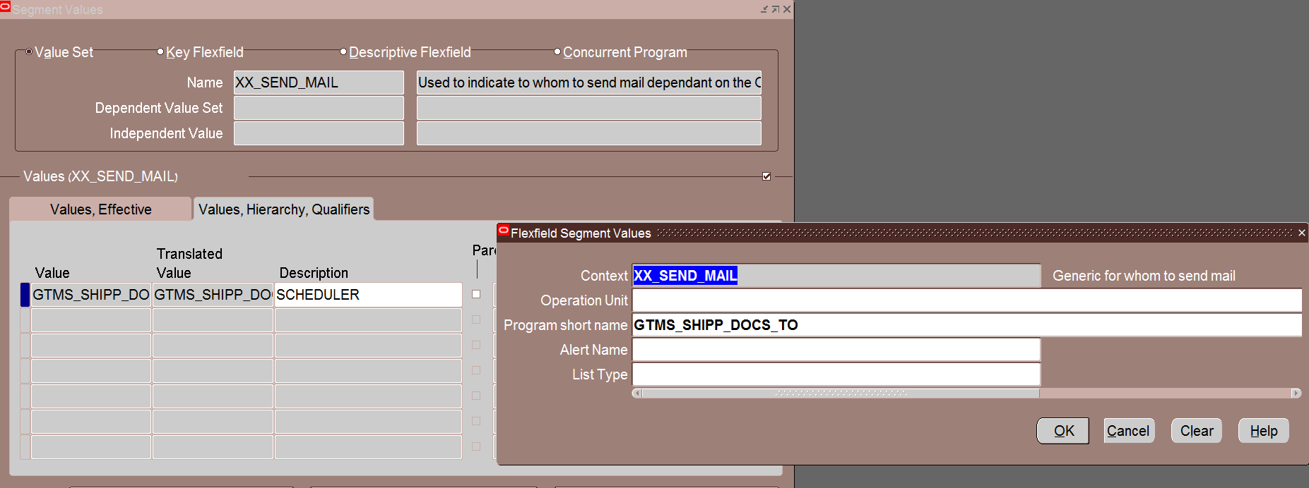

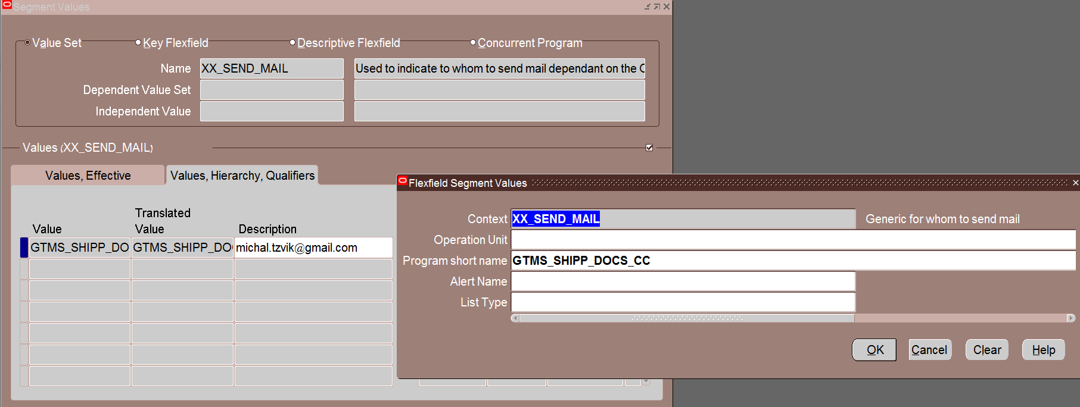

Restriction/Incompatibility

Testing

Navigations

Testing emphasis: (performance, pilot, regression etc)

The navigation to get the Waybill field in the application could be done as following :

Responsibility Application Operations – IT USE ONLY

Supply Chain >> Order Entry >> Shipping >> Transactions

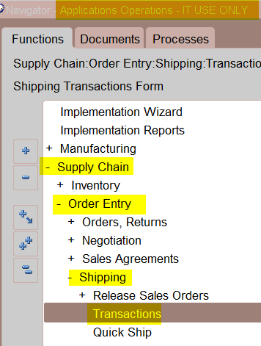

Choose Org Code ITA and limit the line status to Staged/Pick Confirm , click on Find

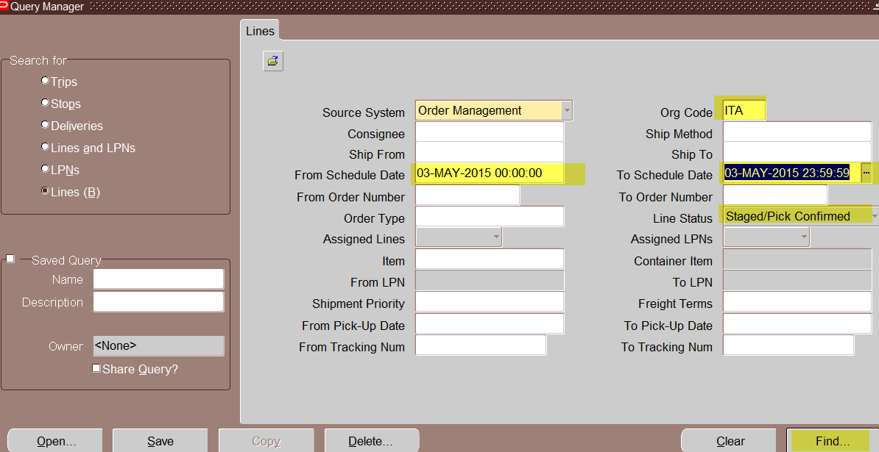

Go to the Delivery tab and click on the Detail… the way bill will be displayed as following

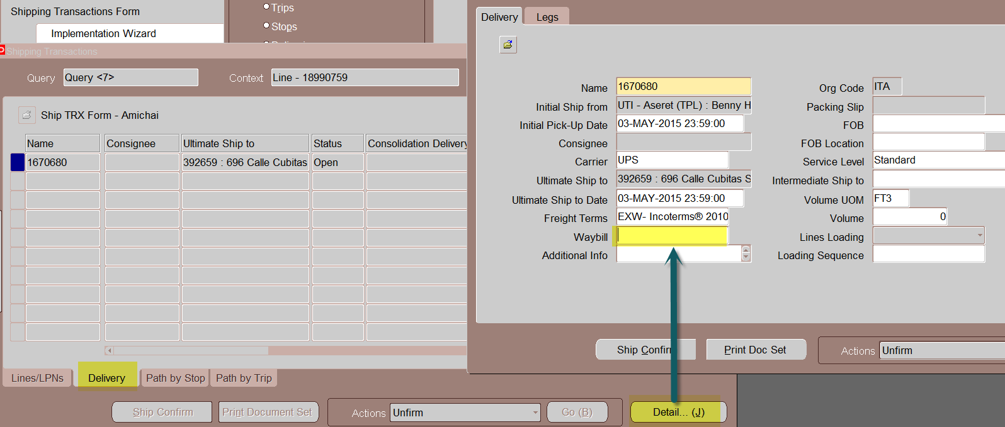

DB source of the Waybill field

Table : WSH_NEW_DELIVERIES

Field name : WAYBILL

Additions/Updates

Functional Spec updates
Rev 1 …

Technical Spec updates
Rev 1

Approvals

Rev. | Description/Details | Created/Updated By | Date | Approved By
1 | Business Owner Approval |  | XX/XX/XXXX

